Name: Christian Alvarez
Date: October 26, 2025
Class: IT2249
Unit: U3D1 Debug and Fix If Statements

Source Code
1. package u3a1_debugfixifstmts;
2.
3. import java.util.Scanner;
4.
5. /**
6. * @author omora
7. *
8. * Christian Alvarez
9. * date: 10/25/2025
10. *
11. * psudocode:
12. * fix the if statements so the program compiles
13. *
14. */
15.
16. public class U3A1_DebugFixIFStmts {
17.
18. // TODO: fix the if statements so the program compiles
19. public static void main(String[] args) {
20.
21. System.out.println("Teacher's Copy");
22. Scanner input = new Scanner(System.in);
23.
24. // prompt the user to enter 3 ints
25. // and read them into
26. // firstChoice
27. // secondChoice
28. // thirdChoice
29. System.out.print("Enter three integers: ");
30. int firstChoice = input.nextInt();
31. int secondChoice = input.nextInt();
32. int thirdChoice = input.nextInt();
33.
34. //Determine & print the state of choices made
35. // fix: restructure the if-else statements to have correct inplamentation
36. // fix: added checks for the variables to determine the number of choices made to the if statements
37. if (firstChoice == 0 && secondChoice == 0 && thirdChoice == 0) {
38. System.out.println("State of choices: \n" +
39. "no choices made yet");
40.
41. // fix: changed if into else if for better logic. else if statements to check conditions for secondChoice and thirdChoice correctly
42. } else if (secondChoice == 0 && thirdChoice == 0) {
43. System.out.println("State of choices: \n" +
44. "user made first choice (" + firstChoice + ")\n" +
45. "number of choices = 1");
46.
47. // fix: added else if statement to correctly check conditions
48. } else if (thirdChoice == 0) {
49. System.out.println("State of choices: \n" +
50. "user made first choice (" + firstChoice + ")\n" +
51. "user made second choice (" + secondChoice + ")\n" +
52. "number of choices = 2");
53.
54. // fix: moved print statement to else block to check all remaining cases and add semicolon to end of print statement
55. } else {
56. System.out.println("State of choices: \n" +
57. "user made first choice (" + firstChoice + ")\n" +
58. "user made second choice (" + secondChoice + ")\n" +
59. "user made third choice (" + thirdChoice + ")\n" +
60. "number of choices = 3");
61. }
62. }
63.
64. }
65.

Screenshots
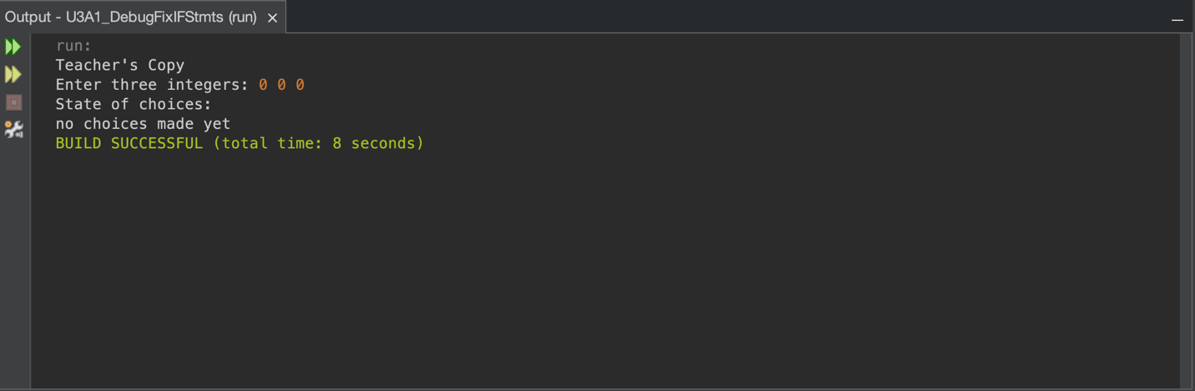
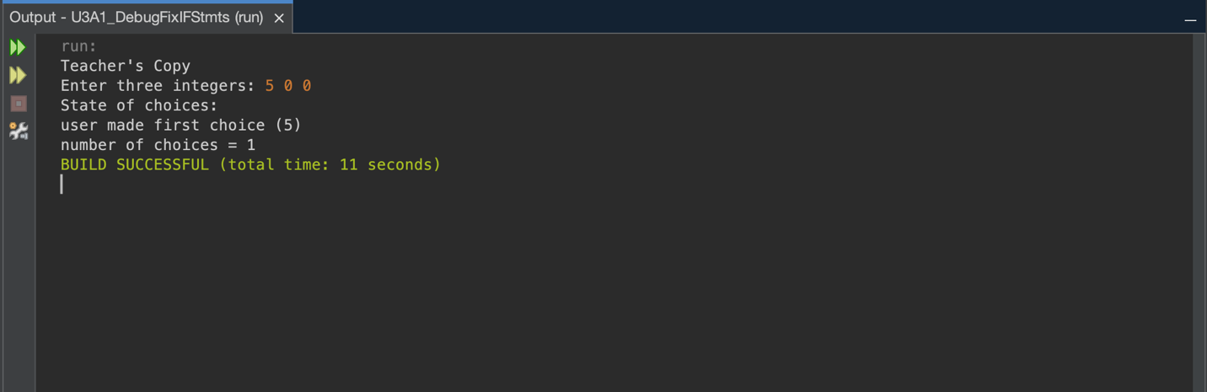
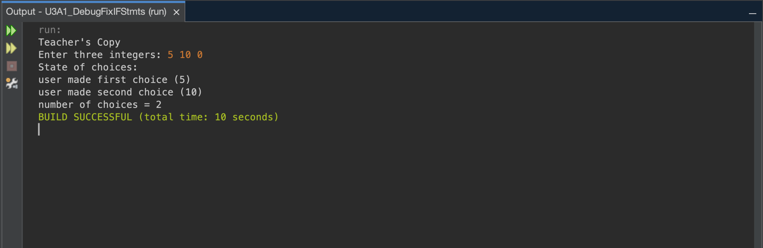
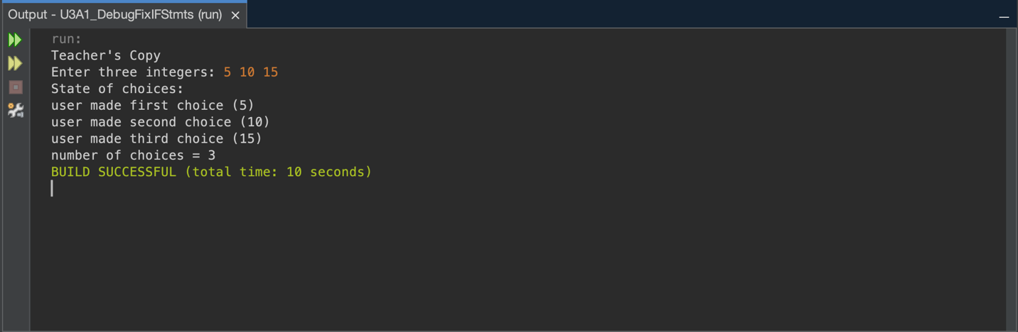
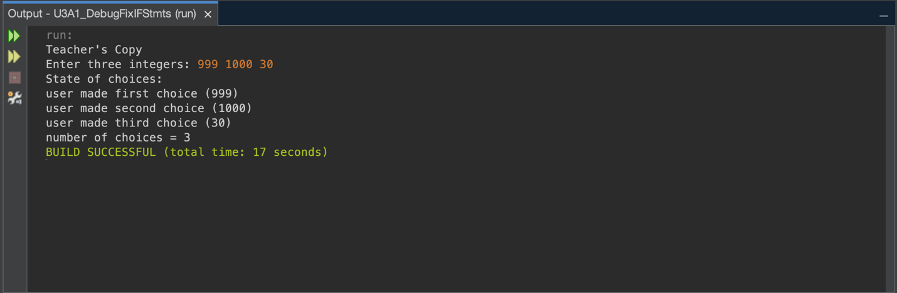

Explanation
Bugs Identified and Fixed
The original program had five bugs preventing compilation and correct execution. The first bug was using three separate if statements instead of an if else if else chain, which caused multiple messages to print for a single input. The second bug was using the assignment operator (i.e. =) instead of the comparison operator (i.e. = =) on line 43, which generated a type mismatch error because if statements need boolean expressions. The third bug was a missing semicolon at the end of the last print statement. The fourth bug was the final print statement not being in an else block, so it executed at the wrong times. The fifth bug was missing compound conditions using the logical AND operator to check multiple variables together.
I identified these bugs using NetBeans IDE, which highlighted syntax errors with red underlines and provided detailed error messages. Testing different inputs and comparing them to the sample output revealed the logic errors. I fixed the bugs by restructuring the control flow into if else if else, changing “=” to “= =”, adding the missing semicolon, moving the final print to an else block, and implementing compound conditions with &&.
Approach and Testing
I started by attempting to compile the code in NetBeans. The IDE immediately flagged syntax errors, which I documented. I decided to fix syntax errors first since those prevent compilation entirely, then addressed the logic problems. After each fix, I tested to verify the change worked without creating new issues.
Testing included six different input scenarios. Test one used 0 0 0 to verify "no choices made yet" printed correctly. Test two used 5 0 0 to check one choice made. Test three used 5 10 0 for two choices. Test four used 5 10 15 for three choices. Test five used negative numbers to confirm they work as valid choices. Test six used large numbers like 999 888 777 to ensure the program handles bigger values. All tests passed and matched the sample output exactly. The program also compiled successfully with no errors or warnings.
Programming Constructs Used
This program demonstrates several fundamental Java constructs. Sequential execution flows from top to bottom unless redirected by control statements. The Scanner class reads user input through nextInt(). Variables of type int store the three user choices. The if else if else structure makes decisions about which code block executes, ensuring only one runs. Comparison operators like “= =” test equality and return boolean values. The logical AND operator (i.e. &&) combines multiple conditions that all must be true. String concatenation with the “+” operator builds output messages by joining text and variables.
Reflection
The biggest lesson was understanding the difference between assignment (=) and comparison (==) operators. Seeing the actual compile error made this concept stick better than just reading about it. I also learned that control flow structure significantly impacts program behavior. Separate if statements allow multiple blocks to execute, while if else if chains ensure mutual exclusion.
Working with compound conditions was trickier than expected. I had to think through all possible input combinations to determine the right conditions for each case. NetBeans made debugging much faster by highlighting errors immediately and providing clear error messages. One challenge was figuring out what output the program should produce, which the sample output clarified. Another challenge was determining the correct compound conditions by working backwards from expected results.
I initially considered rewriting the program with a switch statement, but realized the assignment was about fixing bugs, not redesigning code. This assignment reinforced the importance of systematic debugging: identify the error, understand why it happens, make a specific fix, test it, and verify it works. These skills apply beyond this assignment to real programming work.

